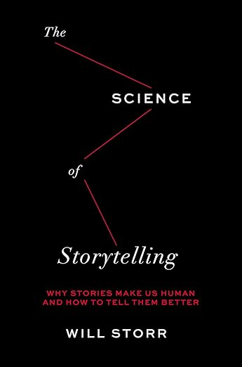

| **English 4 Summer Reading:**  **The Science of Storytelling by Will Storr**  The compelling, groundbreaking guide to creative writing that reveals how the brain responds to storytelling, based on the wildly popular creative writing class.  If you would like to read a different book of similar depth and quality, please email Mr. Fletcher (**lfletcher@philasd.org**) with your idea for approval. Be prepared for discussion and a test based on this text.  **This is a hard deadline assignment. Assignments will only be accepted, for excused reasons requiring a note/email from a parent or guardian with contact information.** | **Google Classroom Code**:  **aqlae4yf**  **Where can you get a book?**  **Your neighborhood bookstore**  → Consider supporting an independent, BIPOC-owned bookstore: [Here are some links](https://www.phillymag.com/news/2020/06/02/philadelphia-black-owned-bookstores/)  **Order used books online:** <https://www.betterworldbooks.com/> <https://www.thriftbooks.com/> <https://www.abebooks.com/> |
| --- | --- |

| **Summer Reading Assignment**   1. **READ and ANNOTATE | Reading Assignment:** Please read the book in full and annotate thoroughly. See the annotation guidelines below. 2. **WRITE | Written Statement:** Compose a brief written statement(250-500 words) in which you:    * Present a poignant quote from the novel (please include the page number)    * Provide insightful analysis of this quote and discuss the relevance of the book in understanding how people write stories. | |
| --- | --- |
|

| **Frequently Asked Questions (and Answers)** |
| --- |
| **How do I check my word count?** *Click “Tools” at the top of your Doc, select “Word Count,” or use the shortcut Command + Shift + C*  **How do I submit my project?** *Turn in your work to the Summer Reading 2025 Google Classroom; make sure you are submitting your work to the correct grade-level assignment*  **What if my project is not digital, and can’t easily be turned in online, or I am not able to join the Google Classroom?** *You may turn in a hard copy of your assignment to your teacher on the first day of school.*  **When is my work due?** ***By 11:59 PM on August 25, 2025 (the first day of school)***  **How will this be graded?** *Your project will be graded for Q1 by your rostered teacher according to the rubric below*  **Who do I go to if I have questions?** *Contact your grade-level teacher for next year with further questions:*   * + **12th grade:** Leonard Fletcher, lfletcher@philasd.org |

| **Summer Reading Project Rubric** |
| --- |
| **Mind blowing (A+) 100-97 points**  The student has created an exemplary piece of writing and earned sophistication points for work that shows a unique understanding, a clearly defined sense of voice, and a refined use of language and/or other modes of expression used.  **Exemplary (A) 96-90 points**  Statement demonstrates a deep exploration of a big question or topic related to one of the novel’s unifying themes. Written statement includes a poignant quote from the text and an insightful analysis of how the book explores a big idea or question inspired by that quote. All requirements are met or exceeded and the whole project gives an impression of neatness, creativity, and care.  **Proficient (B): 80 - 89**  Written statement includes a quote from the text and a surface analysis of the big idea or question inspired by that quote. All requirements are met.  **Developing (C): 70 - 79**  A statement was submitted but may not clearly connect to the novel or explore a big idea or question. A written statement is provided but may be off topic, contain little to no analysis, or not clearly demonstrate a connection between the quote and the project. The project shows minimal creativity or effort and could be neater.  **Incomplete (D/F): 69 points or below** |

| **Annotations** |
| --- |
| **Annotate approximately every other page consistently throughout the book. Along with your thoughts, focus on the following:**  **Clarify**  | Explain what is happening or to make a note when you do not understand any part of the text. This way, you’ll remember to discuss it with a peer or a teacher.  **Summarize**  | Briefly jotting down the main plot points or themes of a section improves your comprehension and retention of material.  **Question?**  | Note any question that comes to mind—no matter how simple or complex. Asking questions of the text keeps your mind engaged and keeps you looking for the answers as you read.  **Predict**  | What do you think will happen next? How is this foreshadowed in this text?  **Define**  | Make a note of any words you do not know AND define them in the margin.  **Connect**  | TEXT TO SELF, TO TEXT, TO WORLD… Does the text remind you of something—maybe a person, a story, a current event, a universal truth in today’s society, etc.?  **Infer**  | Based on the information presented, is there anything that you think the author is subtly revealing rather than stating directly? How? Cite any clues.  **Analyze**  | Break apart and explain any symbols/ characters/themes that you can identify.  **Reflect** | Now that you’ve read a fair amount of the text, have you gained any understanding? Ask “So what? How does this bring meaning to my world?”  **Evaluate** | Make a judgment about the character(s), their actions, or what the author is trying to say.  Critique | Interpret the work by considering what the work reveals about social topics like race, gender, class. |