***AP LITERATURE AND COMPOSITION. 2025-2026. MR. BAVARO (sbavaro@philasd.org).***

Join ASAP → Google Classroom Code: larqu4ss

***.COURSE LOGISTICS AND***

***SUMMER READING ASSIGNMENT.***

***.Due in class on the first day.***

## 

Welcome to AP Literature and Composition! I am so glad you’ve decided to join the class. In this document, you will find some important information and requirements for AP Lit, as well as detailed instructions for the Summer Reading Assignment.

# *A WORD ABOUT THE FOCUS OF AP LITERATURE

**AP English Literature and Composition has a different focus than AP English Language.** In short, in AP Lit, instead of focusing on the question, *how do authors use rhetorical devices to produce an effect on the reader*, students focus on the question, *how do authors use literary devices and other storytelling techniques to affect a reader’s interpretation of a theme about* **humanity and life**. Our reading, writing and discussion will also ***focus on the most valuable aspect of literature: how can we use our reading experience to more deeply understand our own life and the world around us?***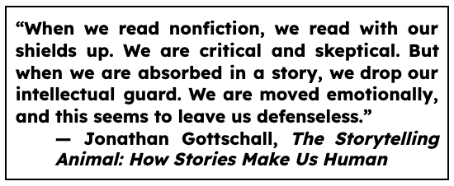

***Also, we read full-length works of literature -- novels, short fiction, poetry, and at least one play. There is considerably more independent reading in AP Lit, and most done for homework. You should plan on having to read (and annotate!) at least 30 minutes each day outside of class.***

# *A FEW LOGISTICS ABOUT AND REQUIREMENTS FOR AP LITERATURE

**Successful AP Lit students** at Rush have a few characteristics in common. Two are about the classes that you have taken thus far: students who do well in the class and on the exam generally have **earned B+ average or better across all English classes in high school and they have passed AP Language**.

More importantly to me, **successful students** are willing to take intellectual risks, try new approaches, are open to reading texts they may not have chosen on their own, are creative but disciplined thinkers, speak often and listen even more, and are willing to see literature from multiple perspectives.

Of course there are exceptions, however if you do not fit this student profile, you should be prepared to put extra time and effort into the class, as well as be patient with yourself around your grades.

**Next: two requirements to be in AP Literature.** ***First*, you must submit the signed *AP Course Enrollment Parent & Student Contract* and return it to the Main office.** This should have already been done, but if it was not, please see me ASAP. ***Secondly*, as noted on the contract, the completion of all parts of this Summer Assignment are required.** **We will be working with *Gatsby* and *How To Read Like a Literature Professor* throughout the 1st marking period.** It will be impossible for you to pass the first marking period without having completed the Summer Assignment. Therefore, if you do not complete it by the end of the first week of school, I will recommend to Dr. Bailey that you be dropped from the course.

**Got it? Ok! Awesome! Onward to the Summer Assignment!**

**Please note: both Part 1 and Part 2 are required.**

**_____________**

# *PART 1: PURCHASE, READ, AND ANNOTATE *HOW TO READ LIKE A LITERATURE PROFESSOR, REVISED EDITION* BY THOMAS FOSTER. (THE RED ONE)

**Important: There are three different versions of this book with different chapters. You must read the Revised edition, published in 2014. It has a red cover. Not a green cover. And not a brown cover. Only the red cover.**

### + Annotate Foster’s Main Ideas -

### *What main ideas about literature analysis does he want you to know as you analyze literature at a college level?*

### + Annotation Foster’s writing style -

### *How does Foster use Rhetorical Devices and other techniques to develop his argument about analyzing literature at a college level*? If you are unfamiliar with Rhetorical Devices, then annotate *parallels that you draw between the book and a piece of literature you’ve read or film you’ve watched.*

+ During the first week of school, you will take a test on this book, so annotate with that in mind.

+ Use any method of annotating you want (colors, symbols, sticky-notes, etc.) as long as those annotations are inside a physical copy of the book. **You are required to include at least 2 annotations per page.**

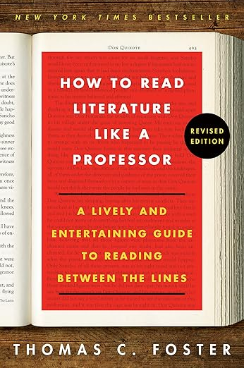

**This one ------------->**

# 

# *PART 2: PURCHASE, READ, AND ANNOTATE *THE GREAT GATSBY* BY F. SCOTT FITZGERALD

**Important note:** Unlike *How to Read Literature Like an English Professor*, you can buy and read any copy of *The Great Gatsby* that you wish. The only difference in the different versions is the page numbers.

***Annotating* fiction, poetry, and drama involves interacting with the text and making meaning of what you are reading rather than simply reading for plot**. Every so often, stop and record your *observations*. Don’t simply note the existence of these elements; **add a note in the margin to elaborate on your observations and connect those observations to the points that the author is making** **about humanity and life, including points about psychological, historical, political, and/or social issues.**

As you write in the margins of *The Great Gatsby*, **jot notes like a human with feelings reacting to these very human characters and situations**. Don’t think about whether your reaction is right or wrong, because all feelings are valid in the experience of literature. So, add these annotations in your own style, language, lingo, colors, symbols, etc. **The more you create these annotations in your authentic conversational voice and for your future-writing-self, the more useful they will be for class discussion and essay writing.**

So, with the above in mind, read and annotate *The Great Gatsby.* **You are required to include at least 2 annotations per page.**

You couldn’t have gotten this far without knowing how to annotate, however, it may be a while since you’ve annotated fiction. **For this assignment, you are expected to note your reactions and add character analysis, as well as write a tiny summary at the end of each chapter. Use any method of annotating you want (colors, symbols, sticky-notes, etc.) as long as those annotations are inside the book.**

### + Reactions: In the margin, make a note next to passages where you react to the characters or situations.

* Think of it like watching a movie - notice and note where and why you laugh, cry, feel anger or suspense, want to yell at a character or feel empathy toward them, etc.
* The goal here is to keep track of your own experience as a reader of this particular text of literary fiction in order to deeply understand the novel.

### + Character Analysis: In the margin, make a note next to passages where you learn about the characters -- who they are and what makes them tick. Keep an eye on details that allow you to have a ‘sketch’ in your mind of the character’s personality, quirks, and growth.

* Although not an exhaustive list, the following are the kind of character details you should notice as you read: *character motivations, hopes, and fears / their desires for the future and their regrets about the past / how they react during internal and external conflict / how they react to the people around them and how others react to them / how they grow and change or stubbornly stay the same / their contradictions and hypocrisy and their humanity / their moments of insight*
* The purpose of analyzing the characters as you read is to help you prepare an AP-Style Literature Analysis essay you will write during the first month of school.

### + Chapter Summary: At the end of each chapter, write a one-to-two sentence summary or bulleted list of the *important* events or situations of every chapter.

* As you know, a *summary* is a brief and concise overview of the main points or events in a text. It condenses the important information into a shorter form. So, don’t over do it. Write just enough to jog your memory of the structure of the novel when you come back to it at the beginning of the school year.
* During the first week we return to school, you will take a comprehension test on the novel, so the goal with these summaries is to briefly mark the factual contours of the novel for you to study.

|  |
| --- |
|  |
|  |

**“We're wired for story. In a culture of scarcity and perfectionism, there's a surprisingly simple reason we want to own, integrate, and share our stories of struggle. We do this because we feel the most alive when we're connecting with others and being brave with our stories - it's in our biology.”**

― Brené Brown, *Rising Strong: The Reckoning. The Rumble. The Revolution.*